**THE POWER OF ARTS IN EDUCATION**

Moumita mondala, Rajib Poddarb, Payel Mondalc and Debopriya Deyd

aB.Tech Computer Science Engineering (1st year), Narula Institute of Technology

bB.Tech Computer Science Engineering (1st year),Narula Institute Of Technology

cFaculty, Department of BS & HU, Narula Institute Of Technology

dFaculty, Department of BS & HU, Narula Institute Of Technology

*Email- [moumitababu2002@gmail.com](mailto:moumitababu2002@gmail.com)

[rjbpoddar@gmail.com](mailto:rjbpoddar@gmail.com)

[payel.mondal@nit.ac.in](mailto:payel.mondal@nit.ac.in)

[debopriya.dey@nit.ac.in](mailto:debopriya.dey@nit.ac.in)

**ABSTRACT**

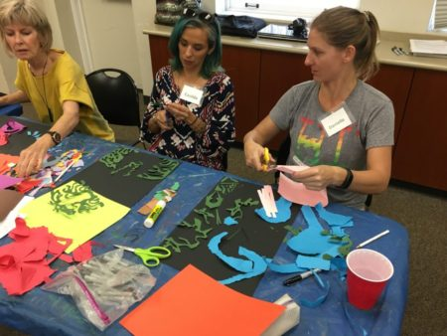**“Art”** is the flow of mind. Being a human, we all have artistic skills in our inner strengths. When we were little, we used to get something writable thing in front of our hands like pencil, chalk, colored pencil, etc., then we would start scribbling on the wall, floor, book, and everywhere. At that moment we didn't even know what we were doing. This is how our parents one day handed us a pencil while we were playing with a pencil. The first thing they teach us is how to hold a pencil, and then they hold our hands and teach us how to draw or write something. But we didn't know at that time what those things were and what happened to them, Is it an alphabet or not? All we knew was that we were drawing something, it has to look like this and it has to be written and drawn like this. When we were kids, we used to remember everything by looking at pictures like tigers, lions, fish, elephants, etc. By seeing them we try to draw them with our imagination. Slowly but surely this way we grew up one day and then our imagination power grew even more. As we grew older, we learned to think about many things. We begin to think about the things we see in our society and what is happening in front of our eyes and we create an image within ourselves. Then we start to draw a sketch of it which displays the image of our thinking in our way. Our thinking process can be expressed by art and in the future, it will visualize our real face of society and improve society through art and it helps to reduce the public hypocrisy of this 21st centuries generation. Not only we can change society but also through art we grow our mentality, and point of view, improve our psychological thoughts, improve our memory and concentration power, build our problem-solving skills, and develop our communication skills.

Art as an educational device functions in a unique location in Waldorf faculties. Creative hobby demanding situations bring out imagination while growing sensitivity for qualitative variations. On the other hand it all the time uses a sense-perceptible medium (color, shape, sound both in song or speech, and so on). A creative hobby is hence the most effective inter-mediator among the bodily conjointly the non-secular factors of the creature while additionally occupying a central role among the kid's play and additionally the adult's work: The perfect that coaching and realistic upload the schoolroom ambitions is to rouse in children a seriousness in the direction of taking part in that filled their being during the quantity as soon as the whole mental content material in their existence turned into to play. Once that is regularly understood inside the realm of coaching and realistic upload the schoolroom artwork is visible inside the proper light-weight there, and it will likely be implemented to the precise extent.

**The Importance of Art Education in Schools:** Art training methods numerous matters to brilliant people, but the crux of it, is that it imparts understanding and training in numerous fields of the arts like music, 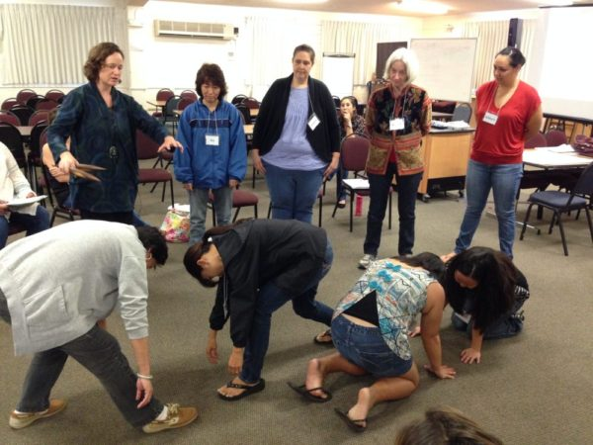theatre, dance, and see arts. Society talents with inside the kind of way now, that a majority of the manual and technical jobs that were completed thru people before, can be completed thru machines. The primary name lies in innovation and creativity, thinking outdoor with inside the priority, and having appropriate interpersonal skills. Just like mathematics or technological statistics, paintings require everyday workouts and are not some troubles that can be completed through sporadic studying. Regular engagement and education inside the humanities desire to be imbibed inside the university curriculum for it to affect the university college students. The most obvious blessing of painting education is that it encourages creativity. Instead of being fed data, they will be capable of finding out their pursuits and take satisfaction in what excites them the most. It improves motor skills, easy things like studying with a paintbrush or using crayons and pencils help growth finer motor skills, especially in extra special children. Studying the humanities furthermore allows enhancing instructional performance, now not without a doubt through creativity, however, it improves reading in regions like math and technological knowledge further to the literary subject. Art education moreover fosters collaboration and enterprise studying. Oftentimes, it brings people and children together, assisting them to check from, and beneficial useful beneficial aid each first-rate as they persevere in the direction of developing some trouble. It improves emotional balance power. It moreover improves accountability, as children claim responsibility for their mistakes and take shipping for their faults while going for walks together. When developing some trouble, the selection of what sun sunglasses and what medium to use is left genuinely to our private alternatives and preferences. Art education lets in improving desire-making boosts self-esteem and make children extra self-assured, as they check what appeals to them, and they at once affect how their final product will look. They can come to be self-learners, constantly hard themselves, and come to be extra targeted in undertaking their goals. Today's global is steeped inside the Information Age. With all sorts of statistics and effects available at our fingertips, it doesn’t remember what we know, but instead how we use what we know. Every academic and professional corporation is looking for what we supply to the table in terms of ideas, innovation, and corporation-playing. Education in the humanities is vital in developing the fundamental, however precis components of human statistics and skills.

By art how many things we can do:

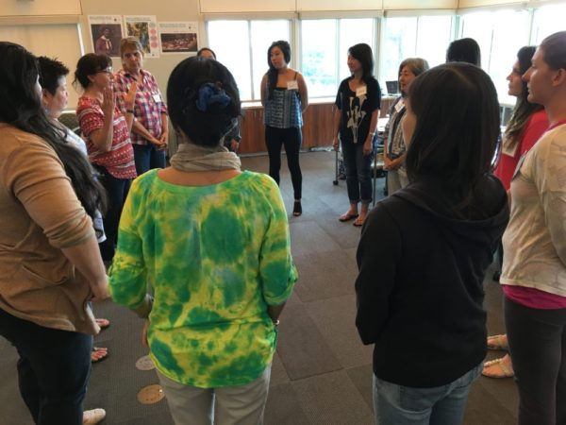**Society development:** Art influences society through dynamic opinions, inculcation values, and translating experiences across house and time. analysis has shown art affects the basic sense of self.

Painting, sculpture, music, and literature, and therefore the alternative art area unit is usually thought of to be the repository of a society’s collective memory. Art preserves what fact-based historical records cannot: however, it felt to exist in a very specific place at a specific time.

Art in this sense is communication; it permits individuals from totally different completely different} cultures and different times to speak with one another via pictures, sounds, and stories. Art is usually a vehicle for social modification. It will articulate to the politically or socially disenfranchised. A song, film, or novel will arouse emotions in people who encounter it, ennobling them to rally for modification.

Researchers have long been fascinated by the connection between art and therefore the human brain. for instance, in 2013, researchers from City University found that viewing up-to-date visual art had positive effects on the private lives of nursing home-bound elders.

Art additionally has utilitarian influences on society. There are demonstrable, correlational statistics between schoolchildren’s grades in science and accomplishment and their involvement with drama or music activities.

As the National Art Education Association points out, art is useful for the creator as an associate outlet for work. Art not solely fosters the human want for style and fulfillment; it's additionally economically viable. The creation, management, and distribution of art employ several.

So what area unit are we waiting for! facilitate foster the inventive we, grab a bottle of wine, and whether or not we return to paint and party with U.S. or value more highly to paint within the quiet of our house, notice our art outlet and release!

**Mental growth:** Through the humanities, students develop skills like resilience, grit, and a growth mentality tohelp them master their craft, act academically, and achieve life when high school. (See Embracing Failure: Building a Growth mentality Through the humanities and Mastering Self-Assessment: Deepening freelance Learning Through thehumanities.) Ideally, this progression can happen naturally, however, usually, it's power-assisted by the teacher. By setting clear expectations and goals forfaculty students, and drawing the correlation between the work done and the results, students will begin to shift their motivation, resultingin a far healthier andextra property learning setting.  
For students toreally grow and progress, there should be a degree once intrinsic motivation comes into balance with accidental motivation. within thefirst stages of learning associate variety, students interact with the activity as a resultof its fun (intrinsic motivation). However, this motivation can enable them to progress solely tothecurrent point, so their development begins to slow -- or perhaps stop. At now, adjoin accidental motivation to continue our students' growth. thismight take theform of auditions, tests, or alternative assessments. similarto the impact of early intrinsic motivation, thiskind of engagement can facilitate our students’ growth and progress. whereas each typeof motivation unit is useful and productive, a hybrid of thetwo is most triple-crown. Our students can study or apply not onlyfor the external rewards, however conjointly dueto the self-enjoyment or satisfaction, but this also offers them.

**Psychological Improvement:** Hobbies are a vital part of maintaining our mental state and eudaemonia. They’re one thing that instantly sparks joy and provides us one thing to be hooked to, likewise as providing us with one thing to concentrate on rather than our daily worries and stresses.

We’ve noticed that several folks click from our painting holidays feeling recharged and invigorated, and it got USA inquisitive regarding the emotional and psychological advantages of painting.

Being in a European nation per week, doing one thing we're keen on, enjoying fantastic food in lovely surroundings with fun, like folks – it’s absolute to place a spring in our step.

**Improves memory and concentration power:** Our brain is figuring out whenever we paint, which implies that painting boosts memory operation and sharpens the mind. above all, painters exercise the components of their brain to blame for memory and concentration.

People who frequently apply inventive activities like painting area units are shown to possess less likelihood of developing Alzheimer’s and insanity. thus, not solely is our painting hobby sparking joy and creating we're feeling higher, it’s conjointly taking care of our health and safeguarding our brain functions for the future!

**Build our problem-solving skill:** Although we tend to attempt our greatest, generally our paintings seldom prove as originally planned! Changes within the lightweight, the restrictions of our palette, and simply plain previous lack of expertise and technique mean that what we begin out attempting to attain generally doesn’t return to life the method that we just expected.

Although this will be frustrating and unsatisfactory, it seems that this will be smart for us! surprising results have 2 benefits: for starters, we pretty quickly learn to agitate disappointment, and in time (often through perennial error) understand that once one door closes, another opens. We quickly learn to adapt and are available up with inventive solutions to the issues the painting presents, and this suggests that thinking outside the box becomes used to the painter!

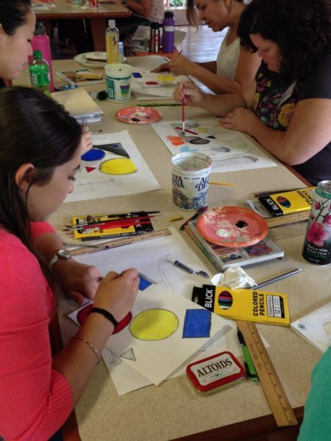Creative drawback finding skills square measure improbably helpful in a standard of living and mean we’re a lot of probably to be ready to quickly return up with an answer once a haul arises.

**Painting can develop communication skills:** Painting helps us to connect with our subconscious mind and permits us to speak our feelings to ourselves and also the outside world through the items we produce. Not only this, however, it additionally, in easy terms, acts as an ice-breaker – providing us with a shared interest with thousands of different artists and art appreciators around the world!

Our painting holidays are pretty social affairs, and inevitably we finish up discussing every other’s art. very little marvel that several come from our holidays not simply with a portfolio of paintings, however additionally an address book filled with new friends!

Our thinking process can be expressed by art and in the future, it will visualize our real face of society and improve society through art and it helps to reduce the public hypocrisy of this 21st centuries generation. Not only we can change society but also through art we grow our mentality, and point of view, improve our psychological thoughts, improve our memory and concentration power, build our problem-solving skills, and develop our communication skills.

**Innovativeness of the Work:** Art is a powerful tool of learning**.** Through arts children can enable to grow in confidence and learn how to think positively about themselves. Art education provides students the opportunity to acquire new skills, discover their creativity and the freedom of self-expression. This paper describes how learning through arts teaches students to look at the visual texts with critical eye, and by creating their own artwork, empowers students to become not only passive consumers of this visual culture, but also creators and manipulators of it.

**Keywords**: Art Education; Communication; Eudaemonia; Creativity; Inter-personal Skills;

**References**

1. Kennedy, Randy. Guggenheim Study Suggests Arts Education Benefits Literacy Skills. June 26, 2006. New York Times.
2. Taylor, P. (2009). Assessment in arts education. Portsmouth, NH: Heinneman.
3. Seidel, S., Tishman, S., Winner, E., Hetland, L., & Palmer, P. (2009). The qualities of quality: Understanding excellence in arts education. Boston: Project Zero, Harvard Graduate School of Education.
4. Catterall, J.S., & Peppler, K.A. (2007). Learning in the visual arts and the worldviews of young children. Cambridge Journal of Education, 37(4), 534-560.
5. Fulton, L. & Simpson Steele, J. (2016). Reconciling the divide: Common processes in science and arts education. The STEAM Journal, 2(3). Retrieved from <http://scholarship.claremont.edu/steam/vol2/iss2/3/>
6. Glass, D., Meyer A. & Rose, D. (2013). Universal Design for Learning and the arts. Harvard Educational Review, 83(1) 98-119.
7. Wagner, T. (2012). Creating innovators: The making of young people who will change the world. New York, NY: Scribner/Simon & Schuster.